**Instructor Signature: ________________________**

**Date: 1/29/2021**

Introduction: In this lab we will be cruising the Raspbian Linux Desktop to see what applications are available and to see what options “pop-up” on each of the menu settings. We will use the LibreOffice Writer to create a short report of your findings to be submitted online.

The Remote Desktop Connection to the Pi will look similar to the Figure below. You will see the IP Address that you typed into to make the connection and the GUI for Raspbian Linux. Depending on the speed of your network this desktop view will pop-up fairly quickly or be really slow. If you have a slow connection be careful of how fast you use the mouse and the number of clicks because it may open up multiple windows, etc.

You can expand, resize, and minimize the remote desktop screen to work on your PC or on the Pi. To capture screen shots with Snipping Tool is real easy; resize the Pi screen and start a new Snipping capture. Once the picture is captured then return to the PC and your Word Document to add the picture to your write-up.

There are a couple of ways to capture your work on the Pi. 1) Resize the window within the desktop and use the snipping tool to capture the Pi Desktop. 2) We can also use a package called SCROT (SCReenshOT) on the Pi to capture images. We can use the command “man scrot” which stands for show me the manual for SCROT the screen capture software. The terminal will update with information about the application and commands to use with SCROT. This application is already pre-installed on the Raspbian OS and does not need to be downloaded.

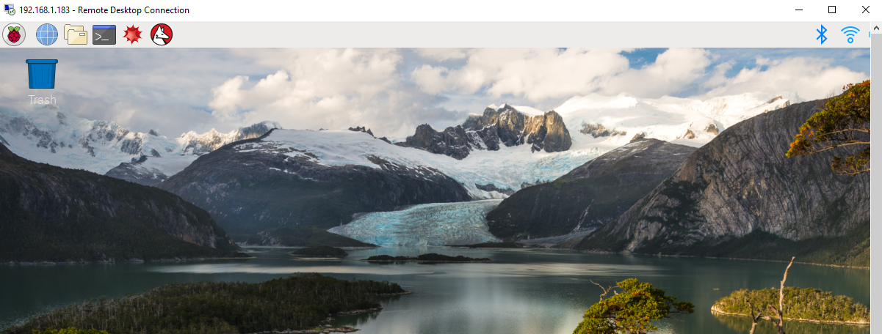

**Outcomes:**

As a result of this activity you will be able to –

1. Demonstrate changing the desktop background picture.
2. Demonstrate changing the start menu by adding and subtracting applications.
3. Demonstrate opening various applications.
4. Installing New Applications using Synaptic
5. Using SCROT to take screen shots on the Desktop

**Equipment and Supplies:**

1. Raspberry Pi Unit with Power Supply
2. PC for Remote Desktop Access
3. Internet Access

To complete Synaptic portion of lab you will need the Pi connected to Monitor, Keyboard, and Mouse.

Procedure I: Identifying the Main Menu Icons on the Left of the Linux Desktop

1. Once you are logged into your Pi let’s start working on identifying the main icons of the Linux Desktop.
   1. 

What are the six icons on the main menu?

Application Menu, Web Browser, File Explorer, Terminal, Mathematica, Wolfram

1. Identify the Main Menu Icons of the Right of the Linux Desktop
   1. 

Bluetooth, Network, Sound, Battery, Clock,

Procedure II: Options Under Each Main Menu Item

1. Under the application menu option what categories are represented by these ICONS?

|  |  |
| --- | --- |
| **ICON** | **Category** |
|  | **Programming** |
|  | **Office** |
|  | **Internet** |
|  | **Games** |
|  | **Accessories** |
|  | **Help** |
|  | **Preferences** |
|  | **Run** |
|  | **Logout** |

Procedure III – Alternate Options (Right-Click Mouse)

Typically in an operating system when you right click with your mouse there are additional options that pop-up depending on what is selected. This activity is about determining if there are additional options when you right-click your mouse.

1. Place the mouse on the desktop in the center. Right-click with your mouse. The options are: **Create New…, Paste, Select All, Invert Selection, Sort Files, Desktop Preferences, Add Icons, Remove Icons, Delete… (Circle All that Apply).**
2. Place the mouse on the ribbon for the Main Menu (Where the Icons Live). Right-click with your mouse. The options are: **Task Bar (Window List)Settings, Add/Remove Panel Items, Remove “Task Bar (Window List)” From Panel, Panel Settings, Create New Panel, Delete This Panel, About (Circle All that Apply)**
3. Click on Panel Settings and see how you can change the appearance of the Ribbon or Add/Subtract items on the ribbon. I am more of a traditionalist and leave mine in the default setting as a preference.

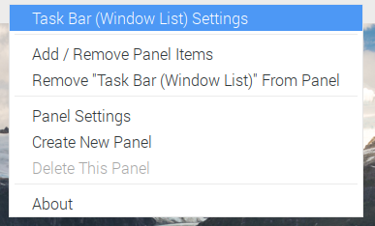

Note: I have not found an easy way of setting the appearance back to the default settings.

1. Click on each of the application items and see the options for programming, office, etc. For example under programming you will see a variety of programming languages that are preinstalled on the OS Raspbian for you to use.

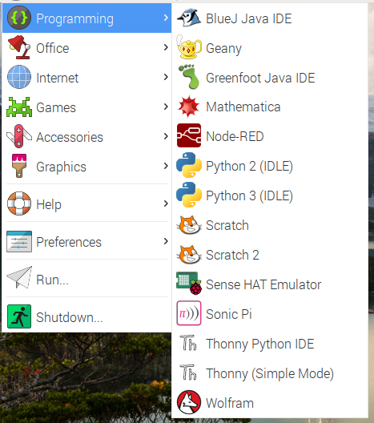

1. To see how interactive applications can be select the Sense HAT Emulator as an option. Click on File and open a basic program example called temperature.

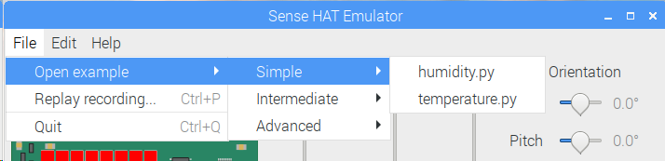

Sense HAT Emulator once open

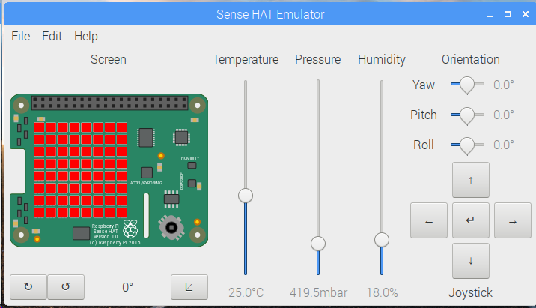

1. The Python program temperature will open and you will notice that is a short code that we will be able to run and then interact with the emulator HAT using the mouse.
2. On the Python menu ribbon there is an option to “Run” the code or press F5. This will open a new Python shell that will echo on the screen that the code is running.

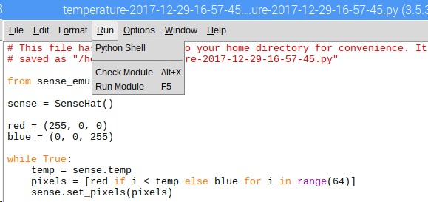

1. Use your mouse to select the Emulator Hat and then move the slide switch for temperature. Notice the colors on the LEDs change from Blue to Red as the temperature changes. Do the other slide switches work? YES/NO Why not? No since this program is for the Temperature slider only.
2. To exit the Python code just close out both screens by using the Red X and say yes to the messages that pops up to kill the program that is running.

Note: These HATs are hardware that attach to the GPIO pins on the Pi so that you can control the hardware via programming code. There are many HATs available to purchase depending on what you are trying to do with your project.

1. Continue exploring the Desktop applications. At the end of your exploration in this section open up Libre Office Writer and type a memo about your experiences with the Desktop and attach it to your submission for this lab.

Procedure IV: Using SCROT

Using ScreenShot or SCROT to capture images on the Pi can be useful when communicating with others about what you are seeing on the screen. If you are needing to create tutorials for others this is an invaluable skill. The current version of Raspbian already has SCROT installed on it.

1. At the prompt type ***man scrot*** and this will give you the manual and options for how to use scrot. The two main options that I use with the application is count down and delay in seconds; that way I can get to the view that I wish to take a screen capture. After reading the manual click q for quit and get back to the prompt.
2. At the prompt type ***scrot –c –d 10*** this will give you a 10 second count down before the screen capture will be taken.

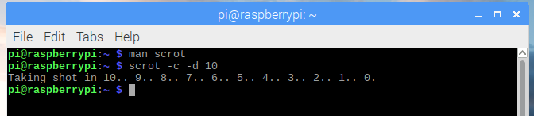

1. Use the folder view icon and find the screen capture picture you took with SCROT.
2. Include the picture in the short letter using Libre Office for the lab synopsis.

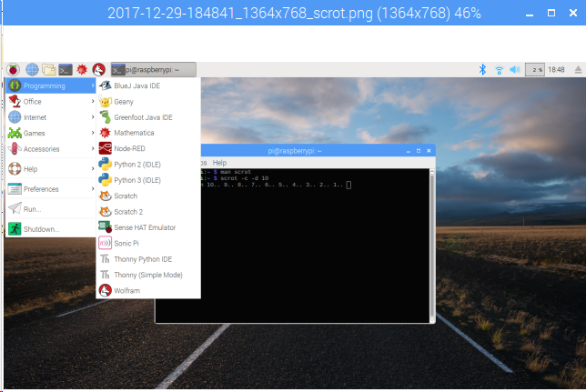

Procedure V: Installing More Packages and Libraries

It really depends on what you want to do when choosing what else should I install on the Pi. We have already installed xrdp or RealVNC for remote access using the terminal but is there an easier way to search and install or remove packages.

To complete this section you need to be connected to a monitor, keyboard, and mouse since the Synaptic package will prompt you for a user name and password that is the root or use RealVNC remote desktop to log into the Pi. The XDRP does not allow access for synaptic.

1. You can see the packages that are already installed by typing at the prompt in terminal ***dpkg --get-selections*** This will bring up the entire list of packages installed currently on the Pi.
2. There are two main ways of installing new packages. Using the terminal and apt-get command to install [known package name]. The second way is to install a package called Synaptic to helps find and manage packages. You must be logged in as the root Pi user (pi and if you haven’t changed the password raspberry) when the prompt from Synaptic shows up.
   1. Open a terminal window and type at the prompt ***sudo apt-get install synaptic.***
   2. After the package list is obtained it will ask you if you wish to continue to ***install; type Y and press enter*** to continue installing.
   3. This may take a bit so feel free to get up and move around or go grab a soda.

Note: The [Raspberry Pi Foundation](http://www.raspberrypi.org/) has created the 'Raspberry Pi Resources', similar to the Play Store or App Store on your phone. You'll find it under the Internet Menu when you're running the GUI on the Pi. There are a few applications that have been written by the Pi community, but this is only a really small selection of what is available.

1. Once Synaptic is installed to access it use the Preferences menu from the application menu

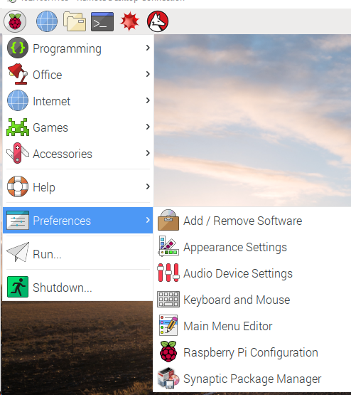

1. Click on Synaptic Package Manager and you will be prompted for a password as Synaptic needs to run as the 'root' user 'pi'. The default password is usually 'raspberry' unless you changed it.

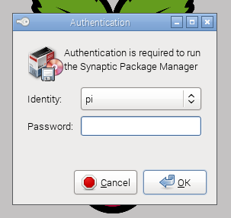

1. You'll see a list of packages on your Pi that can be installed, but first we need to update the list of packages to the latest ones.
   1. Choose ‘Reload Package Information’ from the Edit Menu. You can also press CTRL-R to reload as a short-cut key.
   2. Please wait for the list to update… this does take some time.

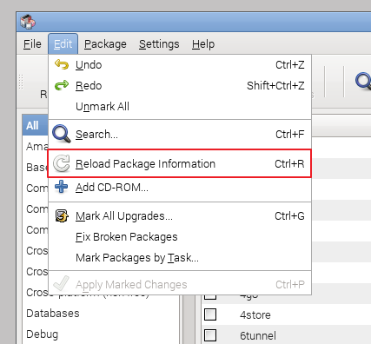

The packages are listed by criteria with the first being 'Amateur Radio', 'Base System' etc.

: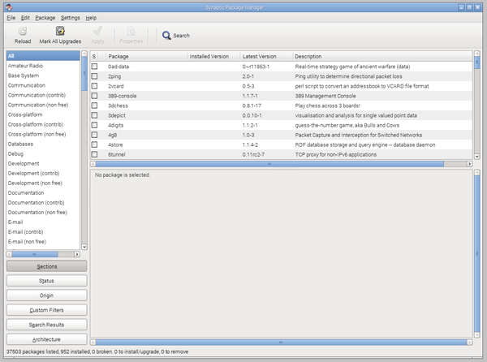

1. At the top of the menu click on the option called ‘Mark All Upgrades’ This will update all of the packages and is the same command done in the terminal ***sudo apt-get upgrade***

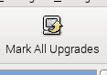

* 1. Upgradeable packages will be listed. Press the ‘Mark’ button to beginning the process.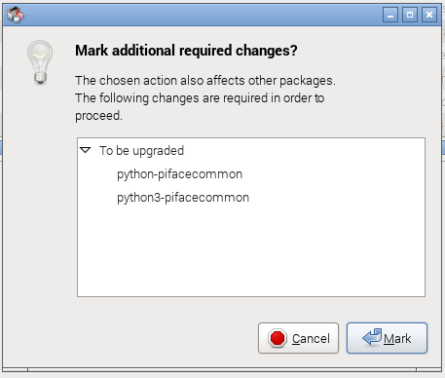

1. Before the upgrades happen you can now scroll and select from the left-side of the menu other packages you wish to install. The majority of the packages will run on the Pi. Click on the ‘tickbox’ left of the name to and in the next menu, select ‘Mark for Installation’. Refer to page 14 for suggested packages.

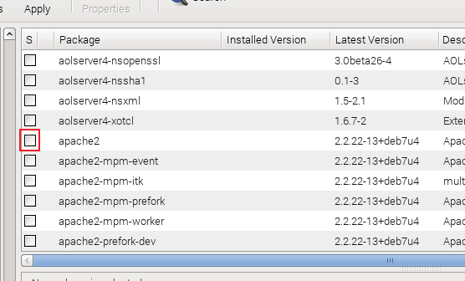

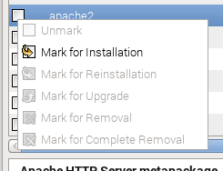

1. Check for additional libraries and other associated ‘dependency’ packages that maybe required or used by the application being installed so that they will be Marked’ for installation.

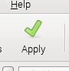

1. After all packages have been ‘Marked’ then click ‘Apply’ at the top to start the installation process. Depending on the number of packages you wish to install this may again take some time to complete.

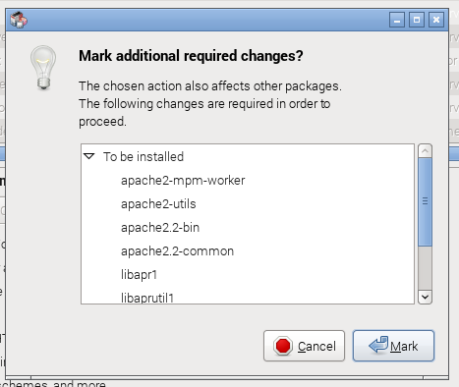

* 1. There will be a summary of what will be installed. Click on the 'Apply' on that screen to finally download and install the packages:

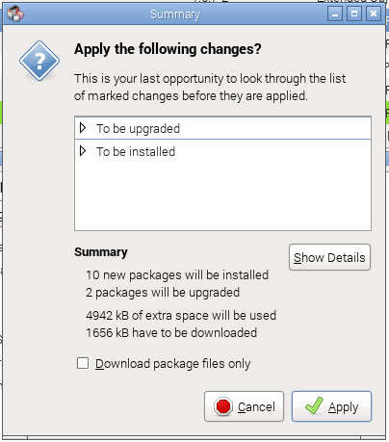

Note: The packages that have a UI will be listed under the Pi’s desktop menu. If a package is large then use the Pi 3 platform instead of an older Pi or Pi Zero. If the package does not work then uninstall it and clean the registry.

**Suggested Packages**

* **gimp** - the GNU Image Manipulation Program - a powerful Photoshop-like photo package
* **arduino** - You can program an Arduino connected to your Pi using this IDE (Integrated Development Environment)
* **fritzing** - A program for drawing electronic circuits
* **chromium** - the Chrome browser (Already installed on Pi 3 OS)
* **apache2** - an advanced Web Server
* **calibre** - an eBook converter and library management
* **libreoffice** - an Office suite, containing word processor, spreadsheet, presentation package and more (Already installed on Pi 3 OS)

Lab Synopsis: Type this synopsis up using Libre Office and include the screen capture shot taken with SCROT.

1. Compare and contrast the similarities and differences between a PC Desktop and the Linux Desktop running on the Pi.
2. List the names and purposes of the icons that are in the application menu.
3. What did you think of the package SCROT?
4. What packages did you install using Synaptic?

Submit this synopsis using the Internet with the Pi. You will need to find the Rogue Community College website and log into BlackboardLearn and then as usual find the assignment title and submit this work.